Placeholder Name of the conference
Placeholder Session title
https://doi.or/10........ DOI placeholder (WILL BE FILLED IN BY TIB Open Publishing)
© Authors. This work is licensed under a Creative Commons Attribution 4.0 International License
Published: (WILL BE FILLED IN BY TIB Open Publishing)
Contribution Title
Subtitle
First Author1[https://orcid.org/0000-1111-2222-3333], Second Author 2[https://orcid.org/1111-2222-3333-4444], and Third Author 3[https://orcid.org/1111-2222-3333-5555]
¹ University College London, UK
² TIB Open Publishing, Germany
³ Technische Hochschule Wildau, Germany
Abstract. The abstract should summarize the contents of the paper in short terms, i.e. in up to 250 words. Please capitalize all major words in the title/heading, including the second part of hyphenated major words (e.g., Self-Report not Self-report). Please also capitalize all words of four letters or more. Please capitalize the keywords.
Keywords: First keyword, Second, Third keyword

1. First section

1.1 Subsection
Please notice that there is no indent in the first paragraph of a section or subsection. There also no indent in the first paragraphs which follow a table, figure, equation, etc.
Nevertheless, paragraphs following other text paragraphs are indented.

1.3 Three levels of headlines may be used
Please only use the formatting styles predefined in this file. Use the “Standard” formatting for the text. The paragraph format is justified. Please use hyphenation. Please do not use footnotes.
Table 1. Centered table captions should be placed above the tables.
Hazard Class | A 1 to A III
Flash point | < 21 °C / > 55 °C
Density at 15 °C | 720 kg/m3 to 860 kg/m3
Kinematic Viscosity | 0,65 to 4,0 x 10–6 m2/s
Tables and Figures should be centered. Please do not merge cells in tables. Please do not use in-line math in table captions.
- Bullet points may be used
- …
- Numbering may be used, too.
- However, please do not use roman numbers.
Equations should be centred and set on a separate line. All equations need to be numbered 1-n. Please do not use 1a, 1b…
x + y = z (1)
In addition to the equations in the text, Authors must provide in-line math and equations formatted in KaTeX in a separate file. In this file, equations must be numbered as in the Word document.
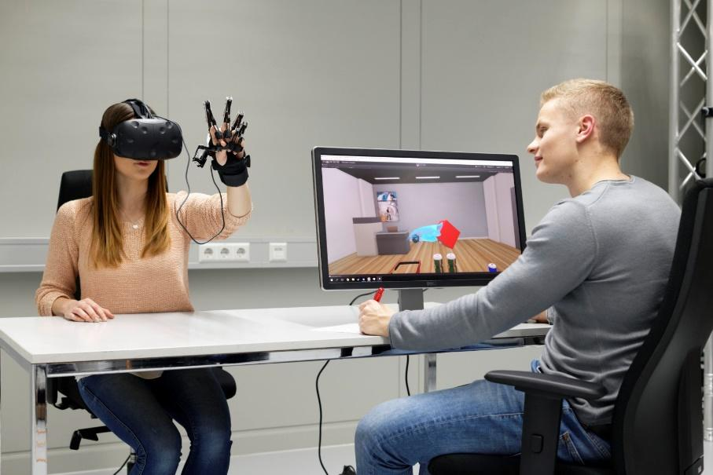
Figure 1. A centered figure caption is always placed below the illustration.
In addition to the embedded figures in the Word file, figure must be submitted as separate jpeg or png. files.
For citations of references, we prefer the use of square brackets and consecutive numbers, e.g. “as shown by Author et al. [2], [3, pp. 5–10]”, “as mentioned earlier [1], [3], [9]”. The first reference mentioned must be [1], the second reference mention [2] etc. Please do not use reference linking in Word. If available, DOIs must be provided. The bibliography below provides the basic formats as a reference list with entries for journal articles [1], book chapter [2], as well as a URL [3]. For further guidance please refer to https://ieeeauthorcenter.ieee.org/wp-content/uploads/IEEE-Reference-Guide.pdf. Please do not forget that data (and other material underpinning the findings) need to be cited in the text and the respective reference must be included in the manuscript’s reference list. Please refer to the data citation principles of FORCE11 or the FORCE11 software citation principles, respectively.

Data availability statement
Please include a statement on how the data supporting the results of your article/contribution can be accessed. If the submission is not based on data or the data it is based on is restricted (third-party data, legal or ethical constraints), this has to be explained in the data availability statement, too. Ideally, data should be deposited in a FAIR-aligned public repository. A registry to find suitable data repositories is re3data.org. Reciprocal linking of data and the article/contribution through persistent identifiers (e.g. DOIs) is best practice.

Underlying and related material
If you have other material which supports your findings (e.g. model code) or is closely related to your article/contribution (e.g. supplementary material as videos, samples, etc.) deposited on a repository, please include a brief description and the respective DOI(s) here.

Author contributions
Please include a statement on authors' contributions according to the CreDIT guidelines here. CRediT (Contributor Roles Taxonomy)’s intention is to recognize individual author contributions, reduce authorship disputes, and facilitate collaboration.

Competing interests
Competing interests arise when issues outside research may fairly be viewed as impacting the work's neutrality. All potential competing interests must be disclosed (“The authors declare the following competing interests: …”). If there are no potential competing interests please state “The authors declare that they have no competing interests.”

Funding
Please insert a funding statement (if applicable) here.

Acknowledgement
If you want to acknowledge persons or institutions you can do so here.

References
- J. K. Author, “Name of paper,” Abbrev. Title of Journal , vol.x, no.x, pp. xxx–xxx, Abbrev. month, year, doi: https.doi.org/……
- J. K. Author, “Title of chapter in the book,” in Title of Their Published Book, xth ed. City of Publisher, (only U.S. State), Country: Abbrev. of Publisher, year, ch. x, sec. x, pp. xxx–xxx.
- First Name Initial(s) Last Name. “Page Title.” Website Title. Web Address (date accessed)

